**Samsung:**

Samsung Galaxy S9 Midnight Black|128GB|5.8" Quad HD|12MP Dual Pixel Camera

₹ 61,900

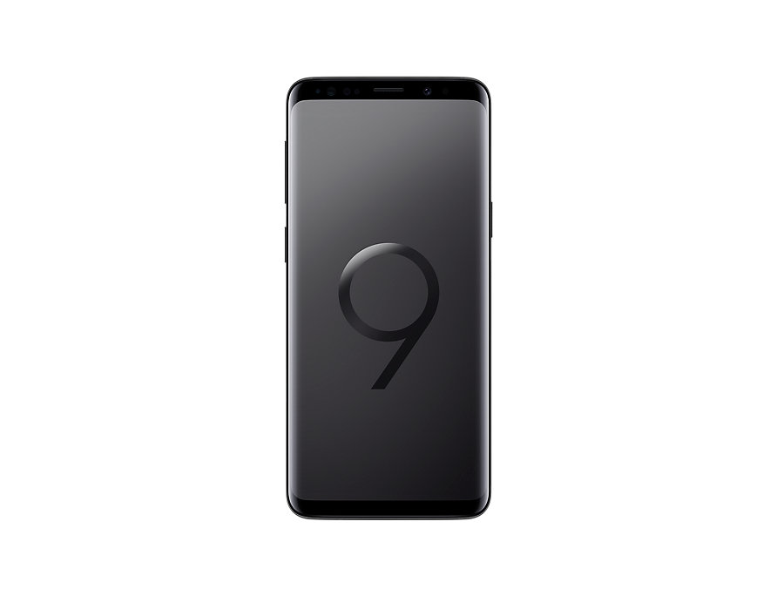

Samsung Galaxy Note 8 (Midnight Black, 6GB RAM, 64GB Storage)

₹ 52,990

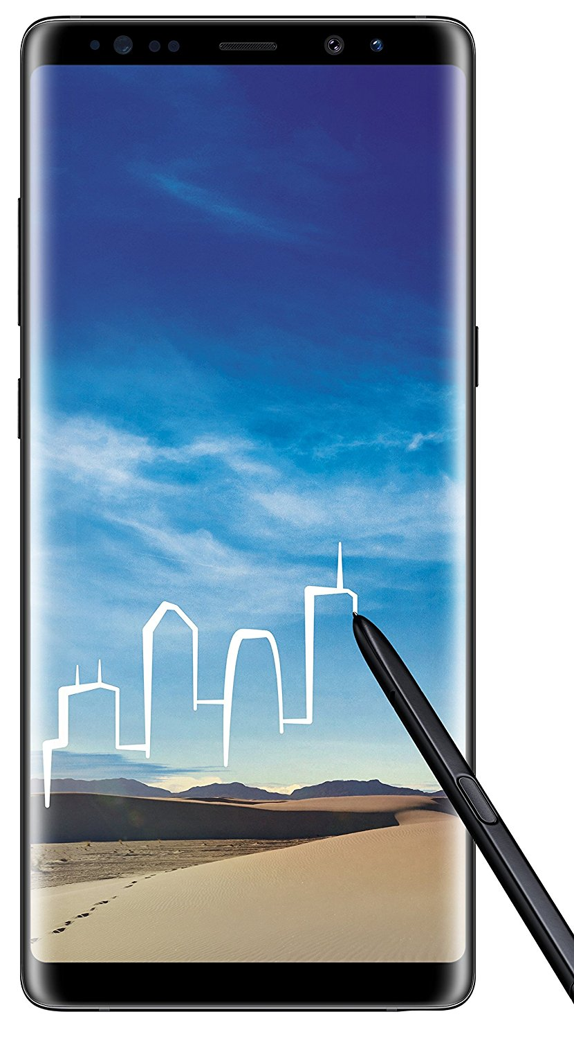

Samsung Galaxy A8+ (Black, 6GB RAM, 64GB Storage)

₹ 29,990



Samsung Galaxy J8 (Black, 4GB RAM, 64GB Storage) with Offers

₹ 16,990

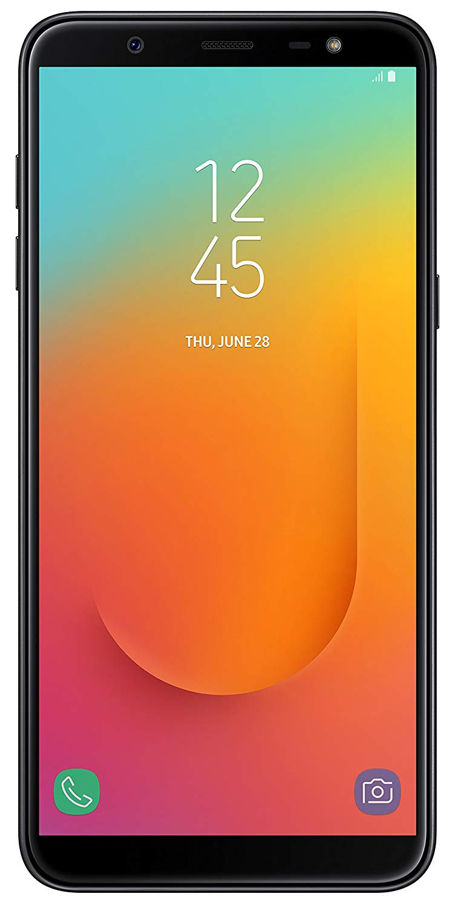

Samsung Galaxy On6 Blue, 64 Gb

₹ 11,990

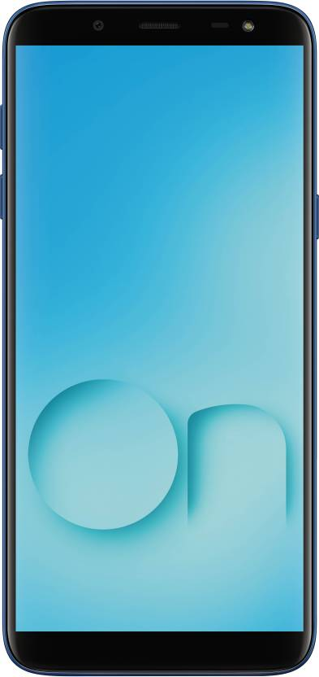

**Apple:**

Apple iPhone Xs (Gold, 4GB RAM, 512GB Storage)

₹ 1,29,900

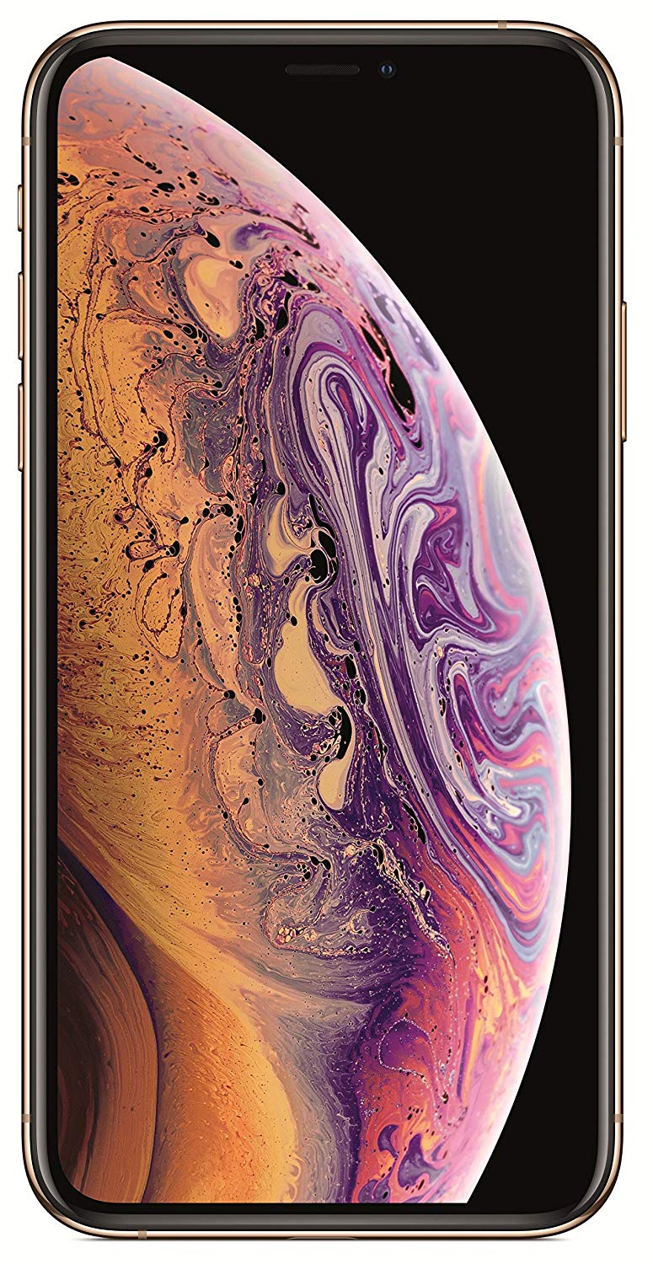

Apple iPhone X (Space Grey, 3GB RAM, 64GB Storage)

₹ 69,999

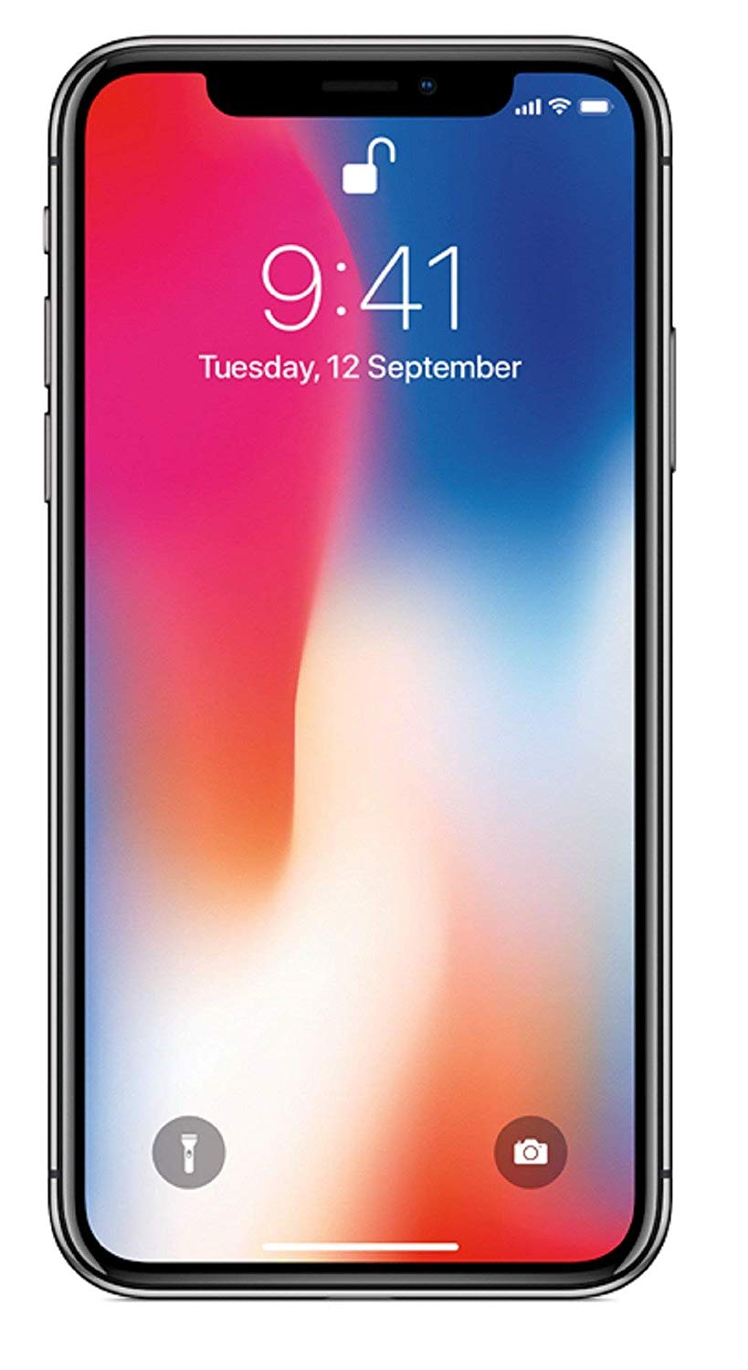

Apple iPhone 8 (Red, 64GB)

₹ 53,999

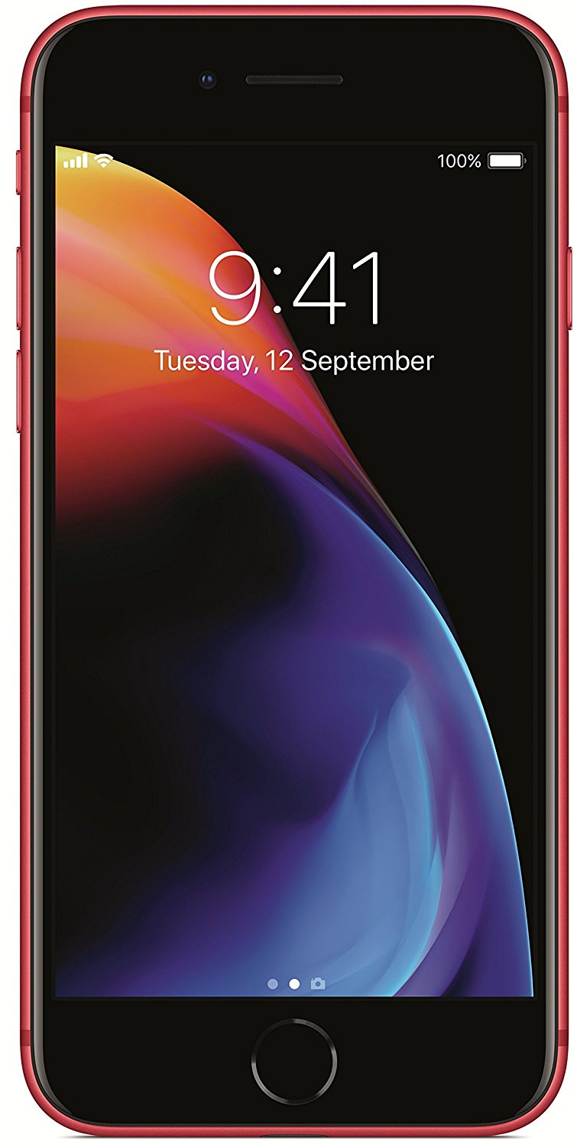

Apple iPhone 7 (Black, 128GB)

₹ 52,400

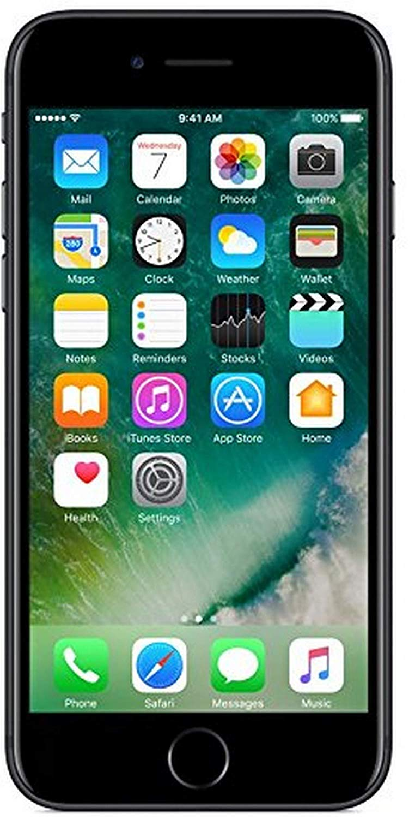

Apple iPhone 6 32GB (Space Grey) Sale

₹ 21,590

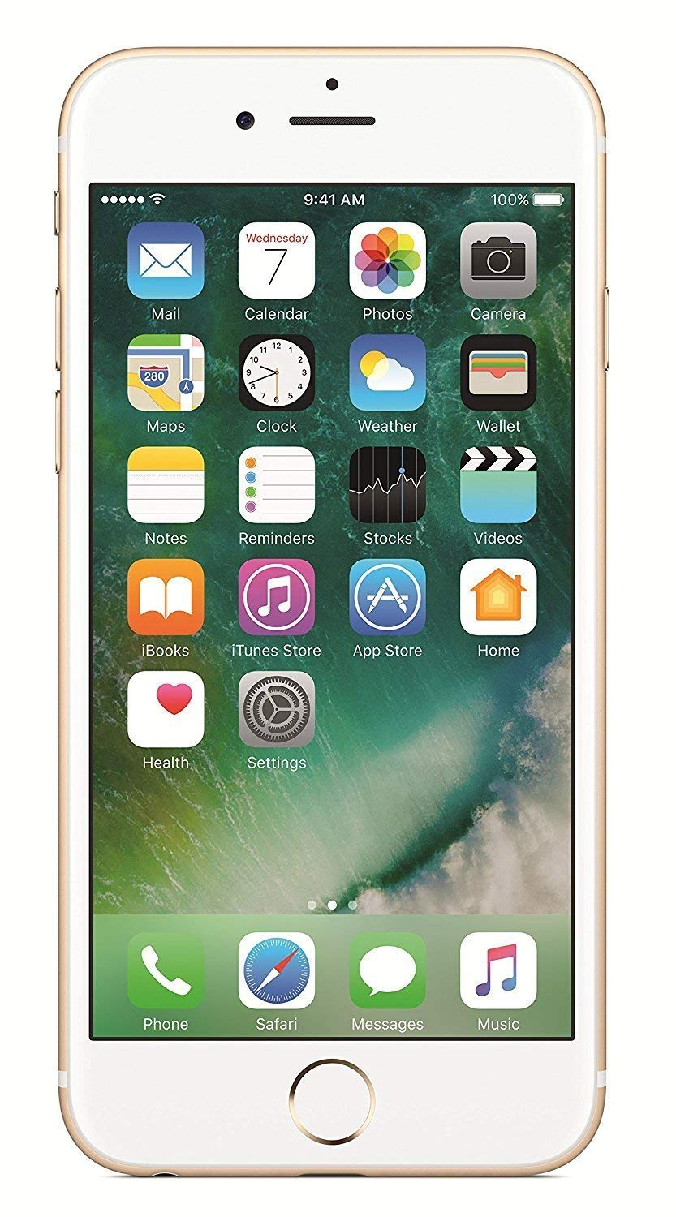

**OnePlus:**

OnePlus 6T (Mirror Black, 6GB RAM, 128GB Storage)

[37,999](https://www.amazon.in/OnePlus-Mirror-Black-128GB-Storage/dp/B07DJD1Y3Q/ref=sr_1_4?s=electronics&ie=UTF8&qid=1541093367&sr=1-4&keywords=oneplus)

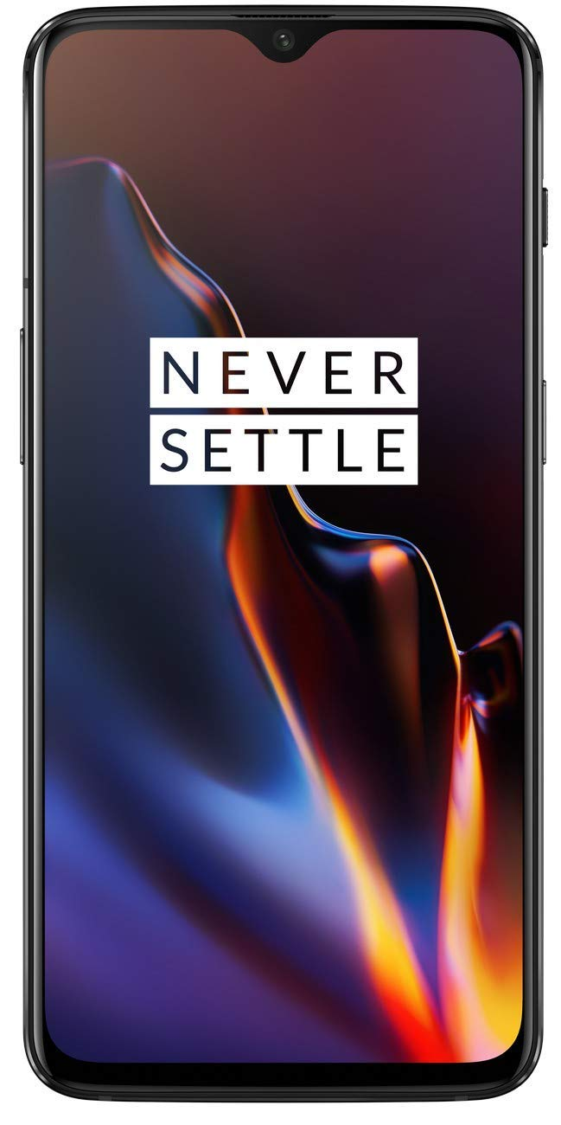

**[OnePlus 6 (Mirror Black, 8GB RAM, 128GB Storage)](https://www.amazon.in/OnePlus-Mirror-Black-128GB-Storage/dp/B0756VRJ25/ref=sr_1_1?s=electronics&ie=UTF8&qid=1541093367&sr=1-1&keywords=oneplus)**

[39,999](https://www.amazon.in/OnePlus-Mirror-Black-128GB-Storage/dp/B0756VRJ25/ref=sr_1_1?s=electronics&ie=UTF8&qid=1541093367&sr=1-1&keywords=oneplus)

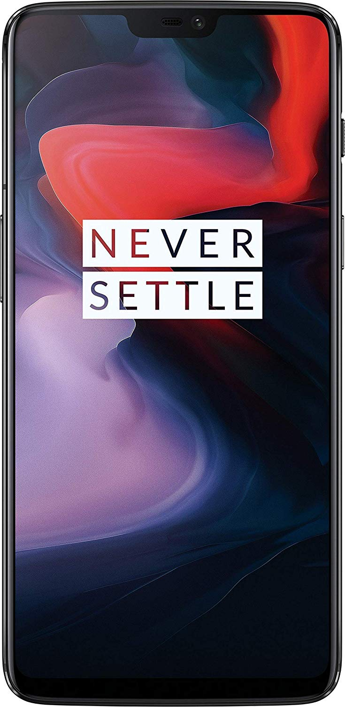

OnePlus 5 (Slate Gray, 128 GB)

₹35,999

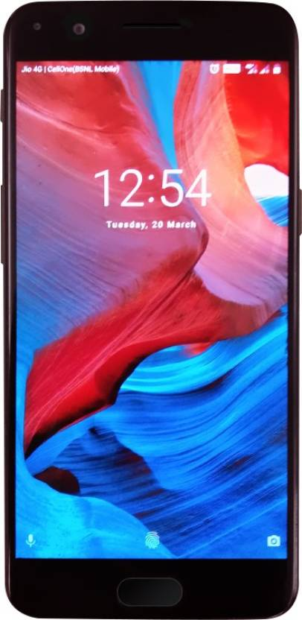

**Xiaomi:**

Redmi 6 Pro (Black, 4GB RAM, 64GB Storage)

₹ 12,999

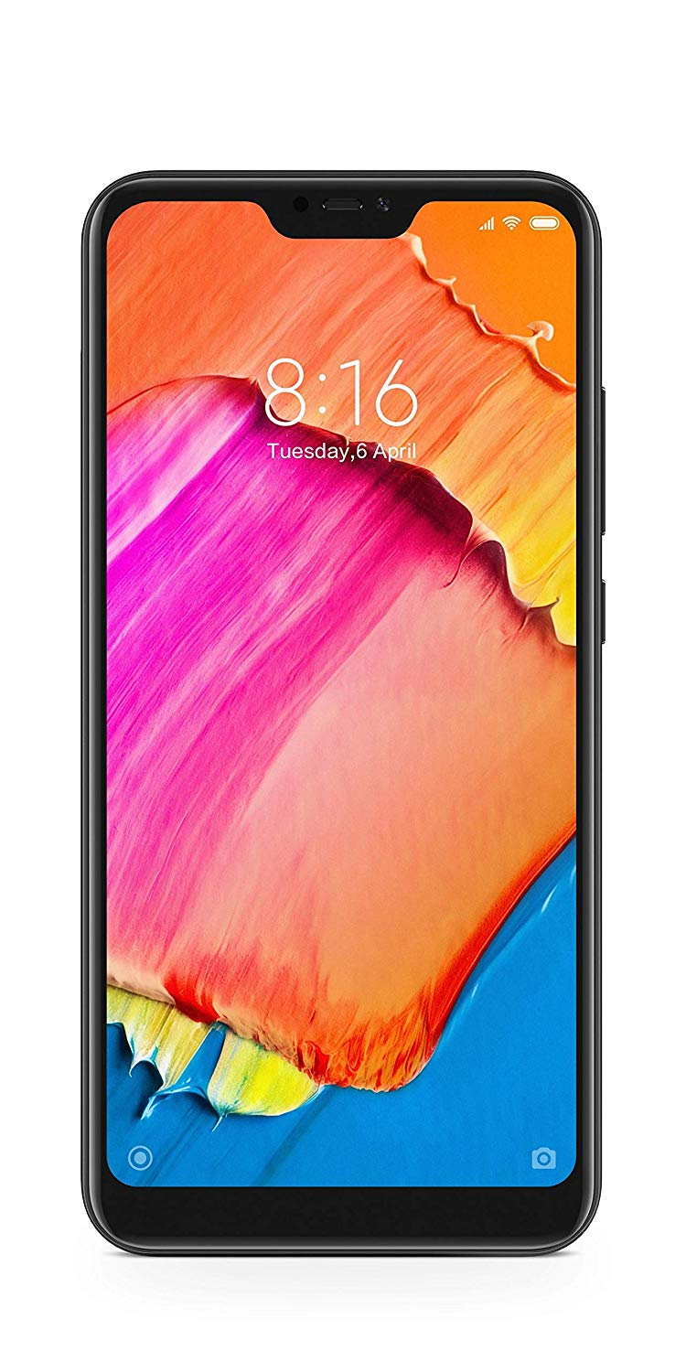

Mi Mix 2 6Gb Ram (128Gb, Black)

₹ 34,504



Poco F1 By Xiaomi Graphite Black, 128 Gb

₹ 21,999

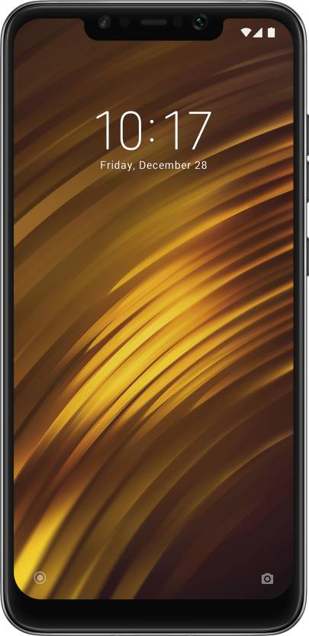

Redmi Note 5 Pro Black, 64 Gb

₹ 12,999

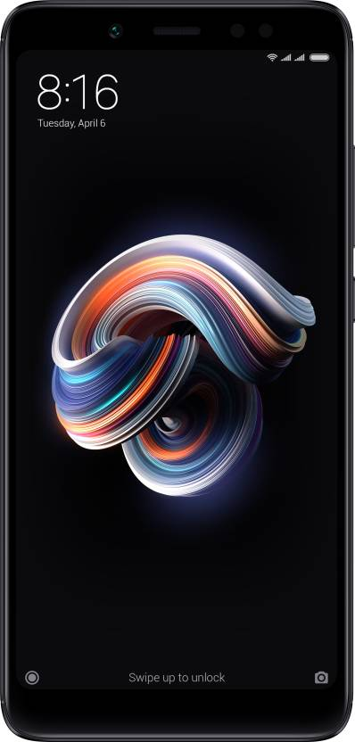

Redmi 6A (Black, 2GBRAM, 16GB Storage)

₹ 5,999

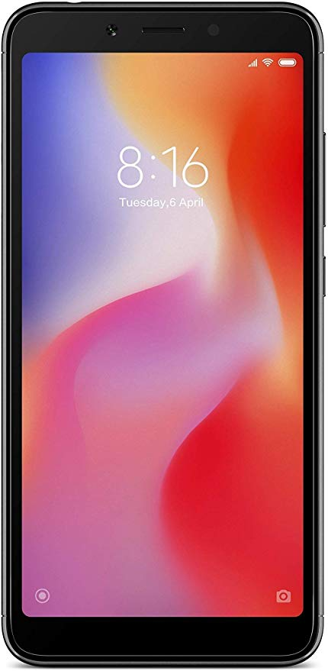

**Huawei:**

Huawei P20 Pro (Blue, 6GB RAM, 128GB Storage)

₹ 64,999



Honor Play (Midnight Black, 6GB + 64GB)

₹ 23,999

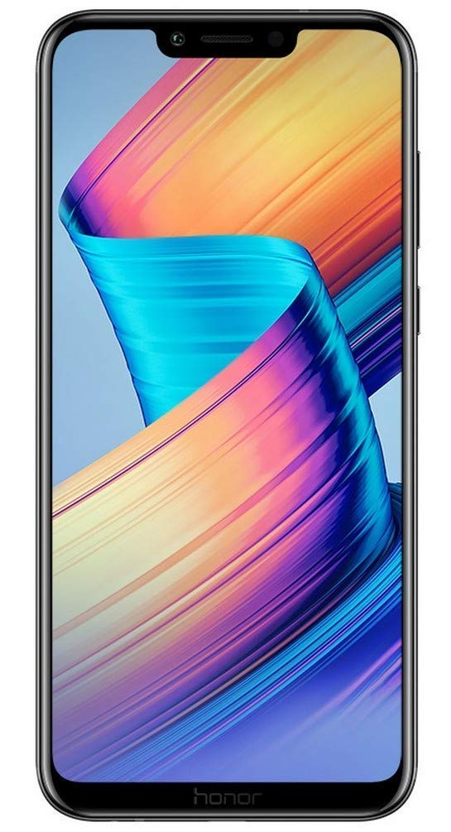

Honor View 10 (Navy Blue, 6GB RAM, 128GB Storage)

₹ 29,999

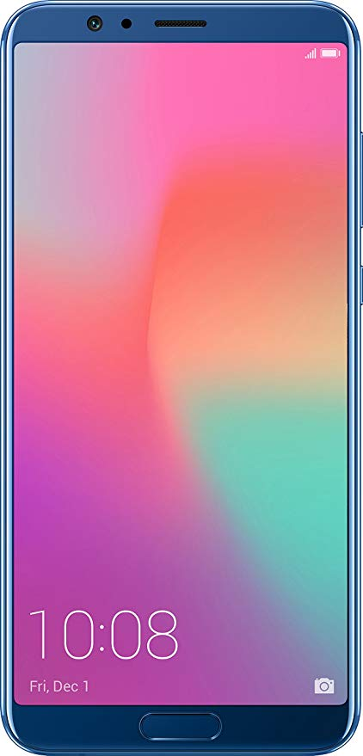

Huawei P20 Lite (Blue, 4GB RAM, 64GB Storage)

₹ 19,999



Honor 9n Sapphire Blue, 64 Gb

₹ 11,999

